**TravelTide Agency Database.**

**Entity Relationship Diagram (ERD)**

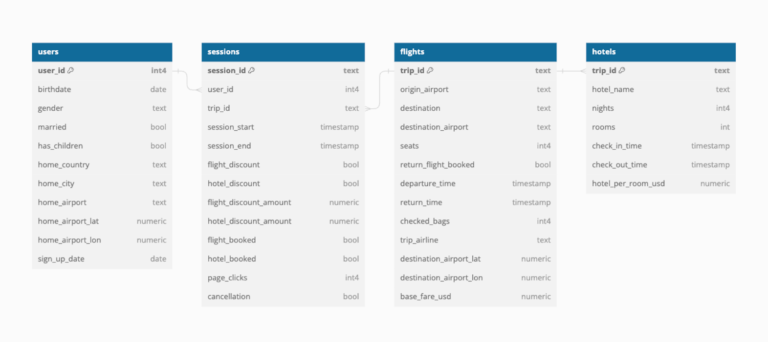

**Data Dictionary**

* **users**: user demographic information
  + **user_id**: unique user ID (key, int)
  + **birthdate**:user date of birth (date)
  + **gender**: user gender (text)
  + **married**: user marriage status (bool)
  + **has_children**: whether or not the user has children (bool)
  + **home_country**: user’s resident country (text)
  + **home_city**: user’s resident city (text)
  + **home_airport**: user’s preferred hometown airport (text)
  + **home_airport_lat**: geographical north-south position of home airport (numeric)
  + **home_airport_lon**: geographical east-west position of home airport (numeric)
  + **sign_up_date**: date of TravelTide account creation (date)
* **sessions**: information about individual browsing sessions (note: only sessions with at least 2 clicks are included)
  + **session_id**: unique browsing session ID (key, text)
  + **user_id**: the user ID (foreign key, int)
  + **trip_id**: ID mapped to flight and hotel bookings (foreign key, text)
  + **session_start**: time of browsing session start (timestamp)
  + **session_end**: time of browsing session end (timestamp)
  + **flight_discount**: whether or not flight discount was offered (bool)
  + **hotel_discount**: whether or not hotel discount was offered (bool)
  + **flight_discount_amount**: percentage off base fare (numeric)
  + **hotel_discount_amount**: percentage off base night rate (numeric)
  + **flight_booked**: whether or not flight was booked (bool)
  + **hotel_booked**: whether or not hotel was booked (bool)
  + **page_clicks**: number of page clicks during browsing session (int)
  + **cancellation**: whether or not the purpose of the session was to cancel a trip (bool)
* **flights**: information about purchased flights
  + **trip_id**: unique trip ID (key, text)
  + **origin_airport**: user’s home airport (text)
  + **destination**: destination city (text)
  + **destination_airport**: airport in destination city (text)
  + **seats**: number of seats booked (int)
  + **return_flight_booked**: whether or not a return flight was booked (bool)
  + **departure_time**: time of departure from origin airport (timestamp)
  + **return_time**: time of return to origin airport (timestamp)
  + **checked_bags**: number of checked bags (int)
  + **trip_airline**: airline taking user from origin to destination (text)
  + **destination_airport_lat**: geographical north-south position of destination airport (numeric)
  + **destination_airport_lon**: geographical east-west position of destination airport (numeric)
  + **base_fare_usd**: pre-discount price of airfare (numeric)
* **hotels**: information about purchased hotel stays
  + **trip_id**: unique trip ID (key, text)
  + **hotel_name**: hotel brand name (text)
  + **rooms**: number of rooms booked with hotel (int)
  + **check_in_time**: time user hotel stay begins (timestamp)
  + **check_out_time**: time user hotel stay ends (timestamp)
  + **hotel_per_room_usd**: pre discount price of hotel stay (numeric)